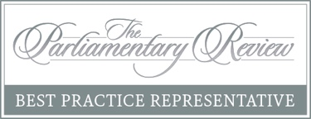
8th September 2020
Dear Parents,
Welcome back to school and to Year 1. I’m sure everyone is very excited to be back and ready to face the year ahead. I’m Miss Morley and I will be teaching your child plenty of exciting things. Below are some of the things we are learning this half-term in English & Maths:
English | Maths
Key text: ‘Traction Man is here’ by Mini Grey  Spelling, Punctuation & Grammar:  - Finger spaces  - Capital letters  - Full stops and question marks  Writing:  - Poems  - Writing descriptions  - Labelling and captions  Reading:  - Phonics sounds  - Recalling the main events from a story  We will also be continuing to have daily Book Talk sessions | Numbers to 10:  - Counting to 10  - Counting to zero  - Ordering numbers  - Comparing numbers  Number Bonds:  - Making number bonds  - Making number stories  Addition within 10:  - Add by using number bonds  - Add by counting on  - Completing number sentence

Overleaf you will find information about what we be learning in our topic ‘What Was Playtime Like at Grove Road in the Past?’ This topic will span the whole of the Autumn term. Included in this are key knowledge and facts that will be covered as well as a list of key vocabulary and definitions. Please ensure that your children are familiar with these words, including the spellings, as they will be using them throughout their topic.
We will be holding this year’s curriculum meeting via Zoom. Below are the details for this meeting:
Date & Time | Meeting ID | Password
Monday 14th September at 4:00pm | 724 6141 5071 | 97MGGN

Please don’t hesitate to make an appointment to see me if you have any other questions.
Yours Sincerely,
Amy Morley
Yellow Class Teacher

